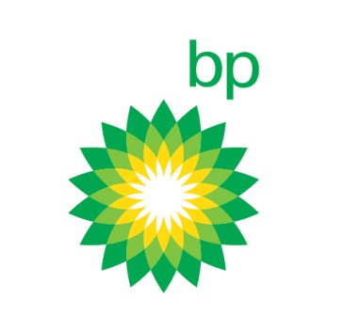

BP（英国石油）北京招聘MARPOL市场分析实习生

Role synopsis:
To understanding of MARPOL project 2020(HSFO to LSFO) implication in China and potential responses from government, shipping companies bunker companies and refineries.

Key accountabilities:
- Under the guidance of BP China Head of Policy to understand responsible government body for MARPOL 2020, potential responses and progress so far.
- Help to deliver the shipping companies research. Shipping companies may solve with a combination of scrubber investment, storage and non-compliance. Need to understand scrubber investment, installation lead-time, shipping companies’ potential choice.
- Summarize input from different sources on potential bunker companies’ awareness on MARPOL 2020 and potential responses
- Provide support to China business by providing refining insight. Refining system may take different response. Need to know how China Oil majors responded to the change in MARPOL 2020 (refining configuration, crude selection etc.)
- Study whether there is any other channels for HSFO e.g. Power sector.
- Deliverable- a study report covering contents above
- Duration- about 2 months

Education / Certifications:
This role requires graduate degree (Masters or senior year students in their doctoral program) in Petroleum engineering or related.
Technical Competencies:
The candidate must demonstrate advanced analytical skills in petroleum industry and communication skill

Core Competencies:
- be able to work to tight deadlines in a fast-paced environment
- be able to access intelligence through network established and different market sources
- be fluent in English, with excellent written and oral communication skills (especially in English)
- be able to apply rigorous attention to detail, but also to stand back and see the big picture

