**Future Petroleum Engineers Forum**

**Beijing, China**

**May11-13, 2018**

**Welcome**

**INTRODUCTION**



**SPE Student Chapter**

**China University of Petroleum, Beijing**

**◆About Us**

SPE CUPB SC grew out of CUPB Youth Petroleum Engineering Association founded in 1995 and we set up in particular a periodical called *The Pioneer*. Later, CUPB Youth Petroleum Engineering Association set a friendly relationship with Society of Petroleum Engineers. Thanks to the joint efforts of many people concerned, the first SPE Student Chapter in China, SPE CUPB SC, was founded in 2005.

Since the foundation, we always keep a close tie with other SPE SCs. SPE CUPB SC aims to provide a platform to fully exploit your potential. You can attend many interstate and foreign activities in different universities. We will offer training and funds for them to participate in domestic or world-class competitions like ATCE, IPTC, APOGCE. We won the first place of APOGCE in 2013, and ATCE Asia-pacific *Petro-Bowl* in 2015. In 2017, we were awarded the second prize in paper contest for undergraduate and PhD group in APOGCE. And the title of Student Chapter and Outstanding Student Chapter were conferred on SPE SCs three times. Our guiding teacher Liang won SPE Outstanding Contribution Award as well as the SPE Innovation Education Award.

**◆About FPEF**

Future Petroleum Engineers Forum, known as National Doctoral Forum before 2012, was an academic forum consisting of several Technical Conferences, Competitions and Talks related to petroleum engineering. We committed to establish a platform for exchanges of knowledge, minds, and research results. It is organized for those who have great passion in fields related to petroleum engineering to share achievements with young generation from all over the world. The forum is sponsored by about **15 companies** annually and will attract nearly **200 students** every yearmajoring in petroleum engineering from over **20 worldwide universities**.

**The 8th FPEF will be hold from May 11th to May 14th in 2018.** Here, you can enjoy the academic and cultural exchange gala. We are looking forward to your arrival!

**◆Competitions and Activities**

**1. Culture Gala**

To deepen cultural exchange, there will be a culture night for all the students. In order to fully enjoy the cultural banquet, we hope you can prepare some programs to share your traditional costume with others. Moreover, Chinese food and culture will present for you.

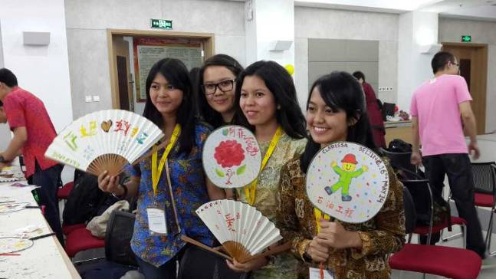

Hand painting fan

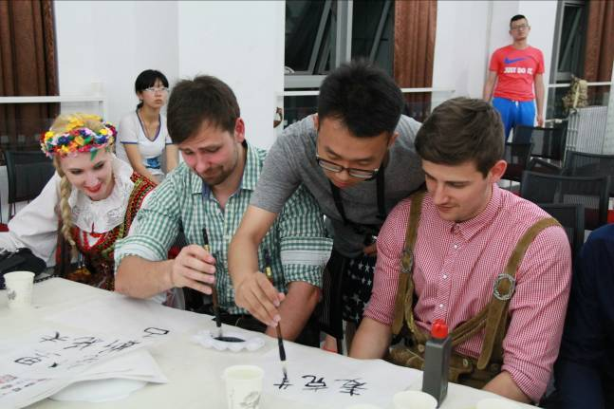

Calligraphy

**2. Cooperation Culture Exhibition**

Cooperation Culture Exhibition aims to advance publicity for the enterprise culture and hold campus recruitment, which will bring together dozens of oil companies each year. You can learn the history of numerous businesses of oil industry, and communicate with HRs person to person. Besides, interesting activities and beautiful gifts will prepare for you.

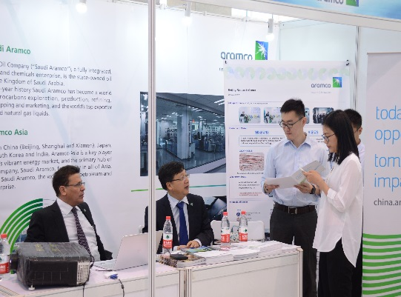 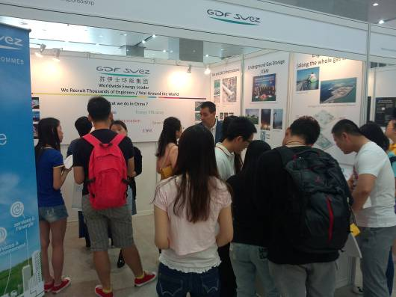

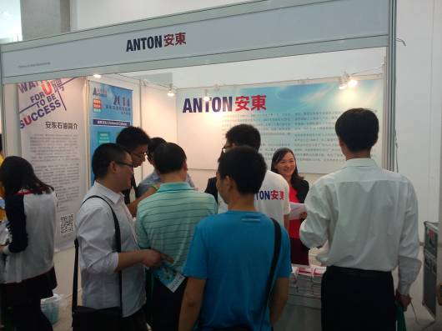 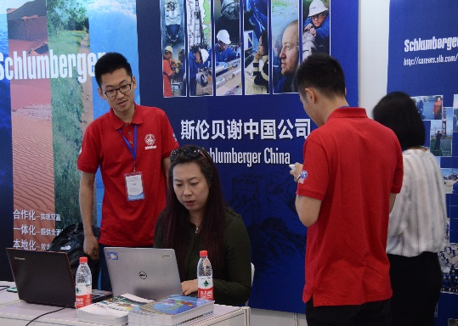

**Cooperation Culture Exhibition**

**3. SPEaking**

**SPEaking** is one of the most featured activities in the Future Petroleum Engineers Forum. We aim at strengthening the academic exchange, broadening the research horizon, stimulating the passion for innovation and helping you grasp scientific concepts. Renowned experts in oil industry would share visionary opinions and deliver speeches.

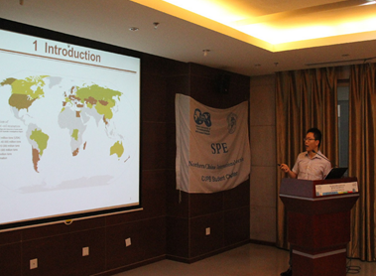 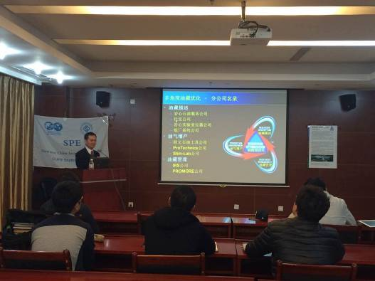

**4. Competitions**

**4.1 Paper Contest**

The Paper Contest, as one of the highlight of FPEF, is a high-level academic platform for you to learn from and communication with young scholars in the field of petroleum engineering. In this competition, you can fully demonstrate your research related to the development of petroleum. After the previous paper submission and the evaluation of experts, excellent paper can be read outin the Forum and be awarded.

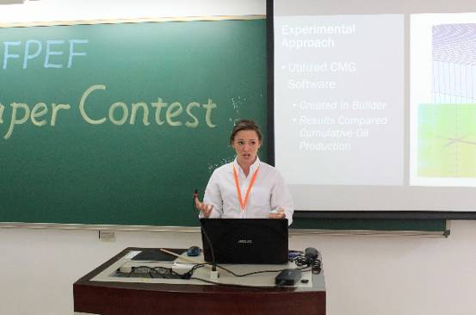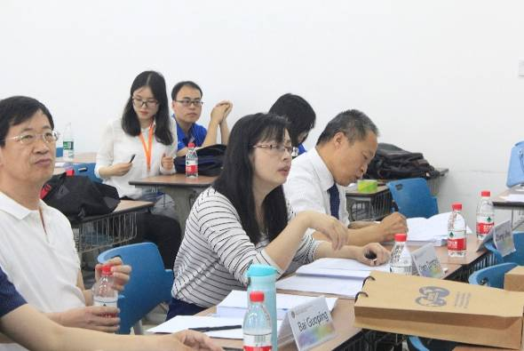

Making Open Reply

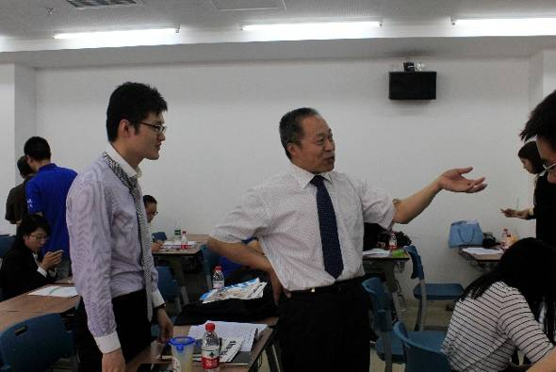

Discuss with Experts

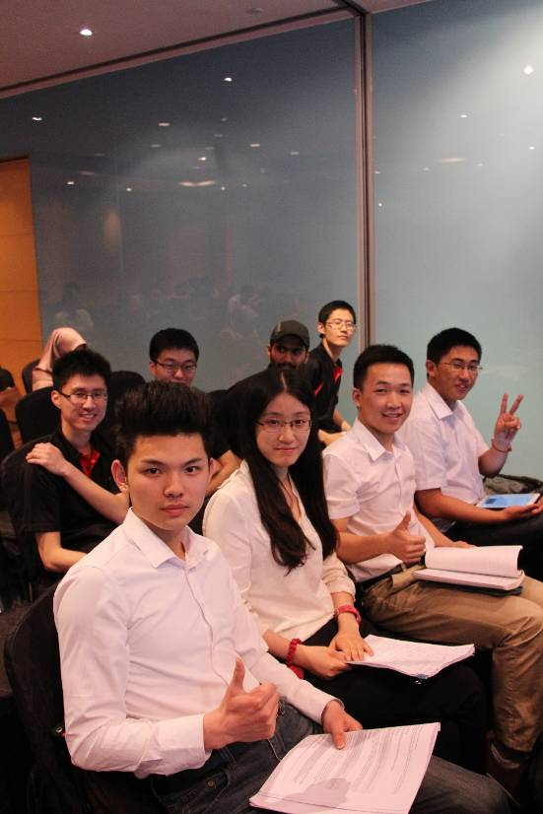**4.2 Petro Cup Competition**

Petro Cup competition targeting all SPE student members is a professional competition on knowledge of petroleum engineering and oil industry. The competition endeavors to broaden your horizon, promote academic exchanges between domestic and foreign universities.

**4.3 Oil & Gas Storage and Transportation Knowledge** **Competition（Domestic studentship only）**

Oil & gas storage and transportation is a high-tech interdiscipline featuring in the storage, transportation and management of city oil & gas. With the development of economy in china, the improvement of people's living standards and the great national strength, there is an ever-growing demand for oil and gas. Oil & gas storage and transportation has gradually become more and more important. As an interdisciplinary course, it required staff to obtain various branches of knowledge, such as engineering mechanics, fluid mechanics, engineering thermodynamics, heat transfer, physical chemistry, pump and compressor, the design and management of oil and gas pipeline, oil and gas gathering, design and management, oil and gas storage and transportation engineering optimization etc.

The objectives of this competition are enriching knowledge related to oil & gas storage and transportation, and improving your speaking, reading and writing ability of professional English of oil & gas storage and transportation.

**4.4 Sinochem Cup Case Analysis Contest**

Case analysis competition aims to enhance your comprehensive competitiveness and actual cases and develop your potential. It will help you to understand the production or management process as well as addressing the practical problem. At the same time, it strengthens exchanges and communication between schools and businesses and provides a platform to demonstrate your ability of self-organization, reaction and the application of knowledge. It may accelerate cultivating people in oil industry.

|  |  |
| --- | --- |
| DSC01489 | DSC01690 |

**◆Join us**

**1.** **Accommodations and Transportations**

As the host of FPEF 2018, we will make arrangements to pick you up at Beijing Capital International Airport(BCIA) on your arrival, and bear the costs of accommodation and transportation in Beijing from May 11th to May 14th. You may fly directly to Beijing Capital International Airport (BCIA). Domestic competitors may arrive at the venue by yourselves. All the round-trip fees should be borne by yourselves.

Venue: China University of Petroleum-Beijing, 18 Fuxue Road, Changping, Beijing China 102249.

**2. Registration and Reference Documents**

Please send the enrolment form to email address: [fpef2018@gmail.com](mailto:fpef2018@gmail.com)

**2.1 Paper Contest**

Appendix 1.1-Application Form for the FPEF paper contest

Appendix 1.2-Format requirement for FPEF

Appendix 1.3-Model Essay for FPEF

Please send us the application form to [fpef2018@gmail.com](mailto:fpef2018@gmail.com) before **April 20th**

Please send us the **paper abstract** and the **paper** to [fpef2018@gmail.com](mailto:fpef2018@gmail.com) before **May 10th**

**2.2 PetroCup Competition**

Appendix 2.1-2018 PetroCup Sample Questions

**2.3 Oil & Gas Storage and Transportation Knowledge Competition**

Appendix 3.1-Application Form for Oil & Gas Storage and Transportation Knowledge Competition

Please send us the application form to [fpef2018@gmail.com](mailto:fpef2018@gmail.com) before **March 31th,**

**2.4 Sinochem Cup Case Analysis Contest**

Appendix 4.1-Application Form for Sinochem Cup Case Analysis Contest

Appendix 4.2-Manual of Sinochem Cup Case Analysis Contest

Please send us the application form to [fpef2018@gmail.com](mailto:fpef2018@gmail.com) before **April 15th,**

Please send us the electronic edition design report to [fpef2018@gmail.com](mailto:fpef2018@gmail.com) before **April 30th**

**3. Contact Us**

**Mr. Songjie Wang | President**

**SPE Student Chapter of CUPB**

**Phone：+86 13263378662**

**E-mail：cupbwang@163.com**

**Ms. Yamin Yan | Vice President**

**SPE Student Chapter of CUPB**

**Phone：+86 18606460762**

**E-mail：13264241759@163.com**

**Mr. Mengge Du | Vice President**

**SPE Student Chapter of CUPB**

**Responsible for airport pick-up，board and lodging.**

**Phone：+86 18911840632**

**E-mail：1510663415@qq.com**

**Ms. Huanhuan Wang | Vice President**

**SPE Student Chapter of CUPB**

**Phone：+86 15611068766**

**E-mail：2017210011@student.cup.edu.cn**